**Jira Screenshots- Backlog with user stories constructing Sprint**

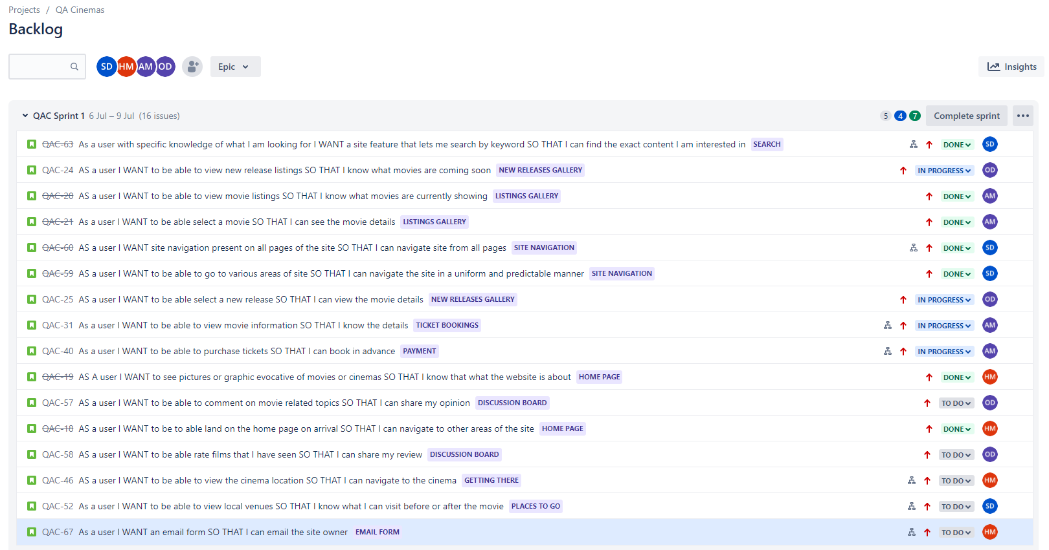

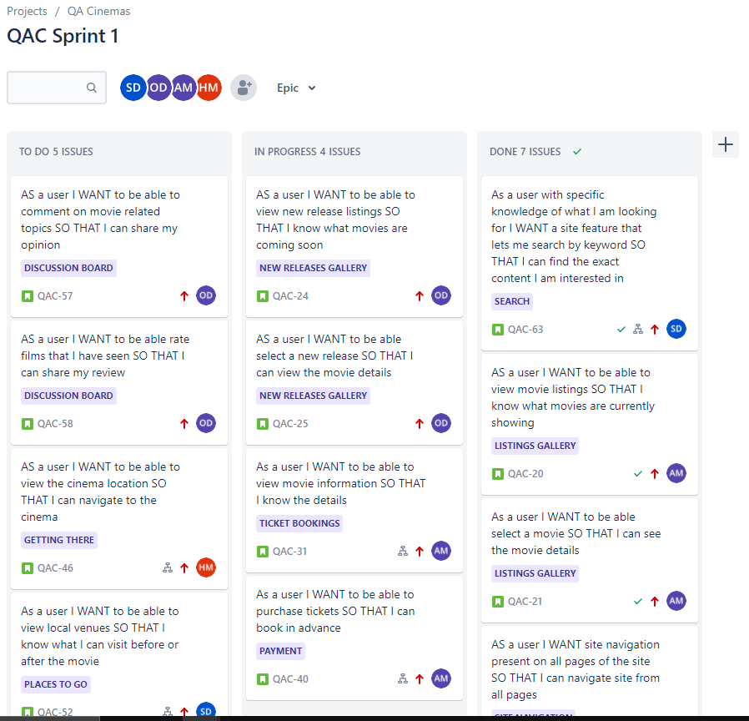**Jira Screenshot- Sprint Board (Sprint 1)**

**Jira Screenshot- Sprint Board (Sprint 2)**

